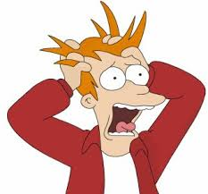
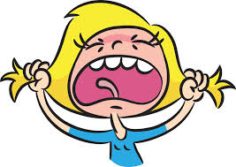
"A Teen's Personal Guide for  Managing Stress" | Visual Text: "Teen Stress 101" | Visual Text: "Stress in Girls vs. Boys"
List three things that can cause stress:  1.  2.  3. | After talking with your partner or group, do you agree or disagree that these are the main stressors in a teen's life? Why? | After talking with your partner or group, do you agree or disagree that these are stressors in a teen's life? Why?
Explain one way that stress can actually be a good thing to experience: | Should any of these items be removed from the list? Why or why not? | What can you notice about the differences in what girls and boys experience stress over most?
What chemicals in your body cause stress reactions? | Should any items be added to the list? Why or why not? | What percentage of students say that they feel pressure to "be" a certain way?  Girls? Boys?
What role do emotions play in how your body experiences stress? | Explain which of these stressors cause you the greatest stress, and why. | Explain why you think that social media is causing teens to be stressed:
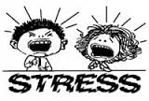
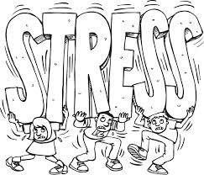
"Helping Teenagers Handle Stress" | "Tapped Out Teens" | Your Reflection
List at least four things that can be a cause of stress:  1.  2.  3.  4. | Describe "Train Your Brain Part I": | What have you learned this week about stress?
What is the "fight, flight, or freeze response" to stress? | Describe "Train Your Brain Part II": | What are the most significant stressors in your life?
What is the "relaxation response" to stress? | How can you capitalize on positive emotions? | Do you think it is possible to reduce the amount of stress in yo ur life?
List five things that you can do to decrease stress:  1.  2.  3.  4.  5. | What are the steps to being an assertive communicator? | Describe one stress-reduction technique that you are going to try as a result of what you have learned this week.

